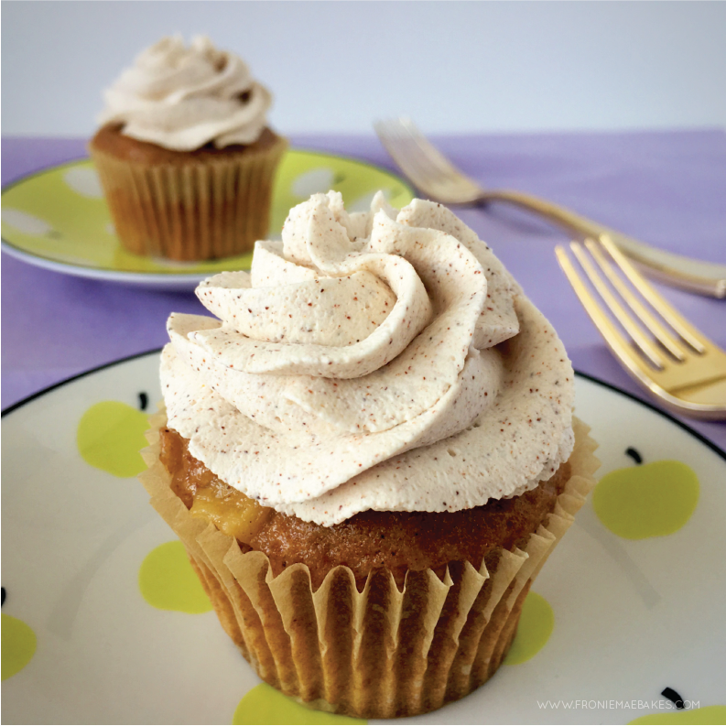
EASY SPICED APPLE CUPCAKES
www.FronieMaeBakes.com

INGREDIENTS:
- 1 Spice Cake Mix
- 21 ounce can of Apple Pie Filling
- 2 eggs
- 1 teaspoon Vanilla Extract

DIRECTIONS:
Step 1: Pour apple pie filling out on a cutting board and chop up apples into bite-sized pieces with a fork. Scoop all of the apples and the filling they came in, into a large bowl.
Step 2: Add the cake mix, eggs and vanilla extract into the bowl with the apple pie filling. Mix together by hand until combined.

Step 3: Place 18-24 cupcake liners into cupcake pans. Fill each liner about 2/3 full of batter.

Step 4: Bake at 350 degrees for 12-15 minutes. Insert a toothpick into the center of a cupcake, if it pulls out clean your cupcakes are done. If batter still appears on toothpick, bake for an additional 2-3 minutes. Sometimes the apple filling leaves "wet" looking spots on the top of the cupcake, but as long as the toothpick test comes out clean they are done.

Step 5: Place cupcakes on a wire rack to cool while making whipped cream or serve them warm with ice cream.

