Buttercream Frosting
www.froniemaebakes.com
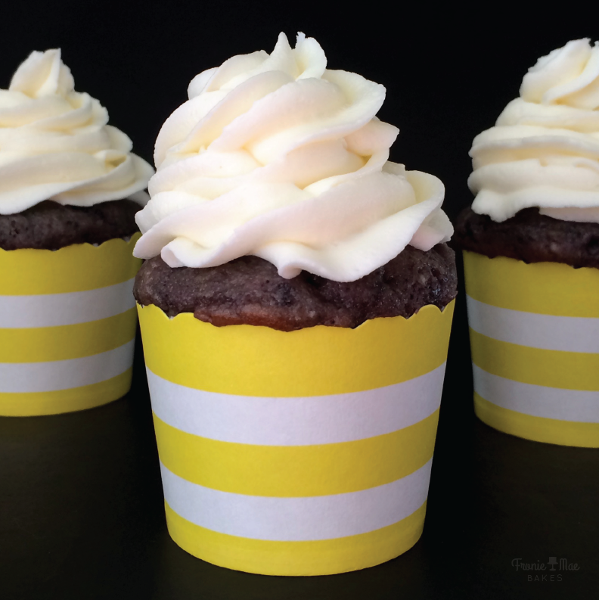
Ingredients:
- 3 cups powdered sugar
- 1 cup soft butter
- 2 teaspoons vanilla extract
- 2-4 tablespoons of heavy whipping cream
Directions:
Using a mixer and a large bowl whip butter and slowly incorporate powdered sugar. Add vanilla and whipping cream. Give your frosting a taste and if it tastes too buttery or the consistency is too runny, add a little more powdered sugar. If your frosting is too thick add a tablespoon of whipping cream to loosen.

