CAFE MOCHA
www.FronieMaeBakes.com
Ingredients:
- 1 tablespoon cocoa powder
- 1 tablespoon sugar
- 1 cup hot black coffee
- ¼ cup of milk
- whipped cream
Directions:
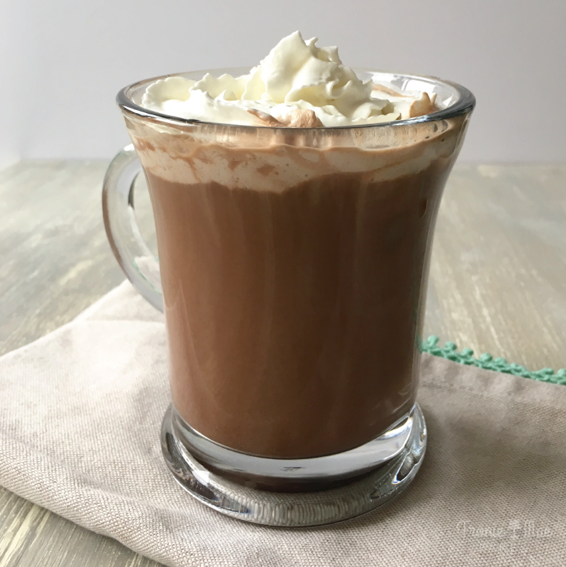
Pour cocoa powder and sugar into a coffee mug, add a small amount of hot coffee and stir until you have something that looks like a smooth syrup. Pour remainder of coffee in and stir, then add milk. Top with whipped cream and enjoy!

