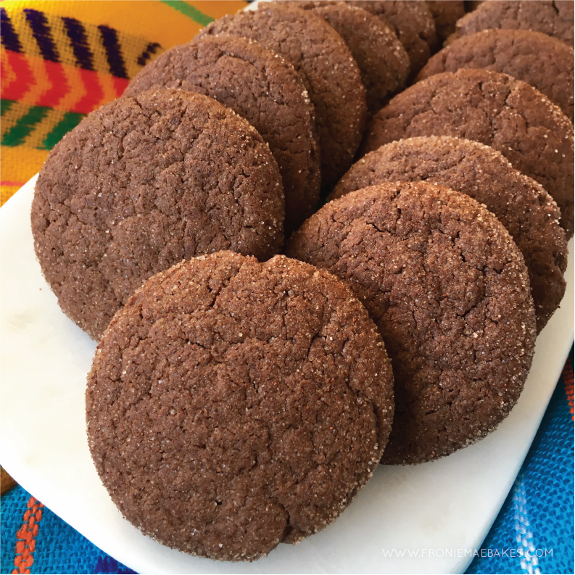
MEXICAN HOT CHOCOLATE COOKIES
WWW.FRONIEMAEBAKES.COM

Ingredients

1 cup salted butter, softened
1 ½ cups granulated sugar
1 ½ cups brown sugar
2 tsp cream of tartar
1 tsp baking soda
½ tsp salt
½ tsp cayenne pepper
4 large eggs, room temperature
2 tbsp vanilla extract
1 cup unsweetened cocoa
4 ½ cups all purpose flour

Cinnamon Sugar Coating

½ cup granulated sugar
4 tsp ground cinnamon

DIRECTIONS

Preheat oven to 350F. OR 325F if you are using a dark non stick pan
In a large mixing bow, beat the butter and sugars together until nice and fluffy.
Mix in cream of tartar, baking soda, salt, and cayenne pepper until well blended.
Next mix in eggs, one at a time, then add the vanilla. Stir in unsweetened cocoa and flour just until combined. Your dough will be thick and heavy.
Combine sugar and cinnamon in a small bowl.
Use a teaspoon sized cookie scoop to scoop out dough then using the palm of your hands form the dough into a ball.
Roll the ball in the cinnamon-sugar mixture and place on the prepared baking sheet. Flatten slightly with the bottom of a glass.

Bake cookies for 10 to 12 minutes. They should be a little soft in the center when you touch them. Transfer cookies to a wire rack to cool.

