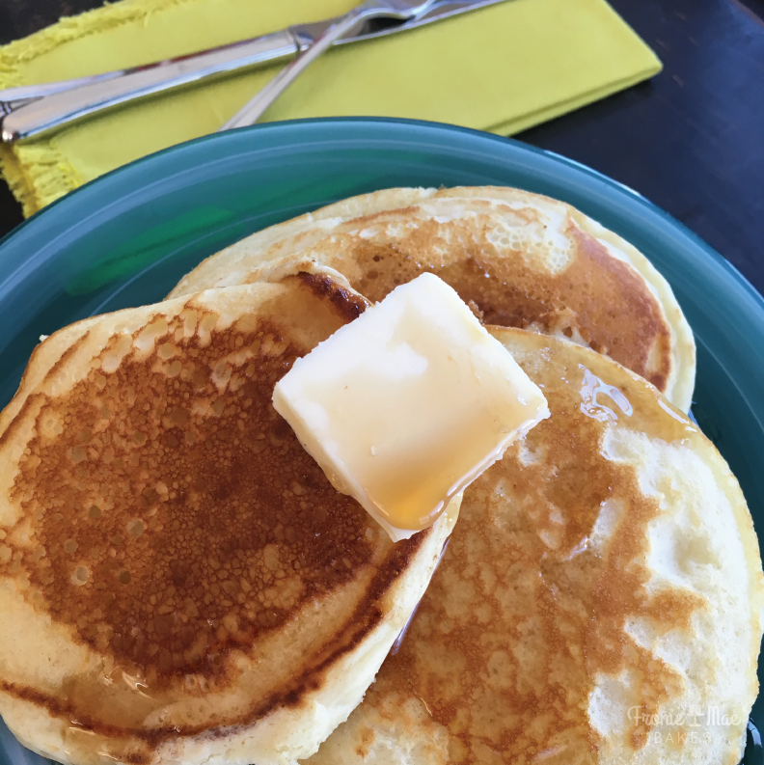
PICK ME UP PANCAKES
www.FronieMaeBakes.com
Ingredients:
1 1/4 cups flour
3 teaspoons baking powder
1 tablespoon sugar
1/2 teaspoon salt
1 egg
1 cup milk
2 tablespoons vegetable oil
1/4 teaspoon lemon extract
Directions:
Sift dry ingredients together. In a separate bowl mix together the egg, milk, oil and extract. Pour the wet ingredients into the dry and whisk until combined. Pour 1/4 of a cup of batter onto a buttered griddle and cook until bubbles start to pop, then flip your pancakes. Enjoy!

