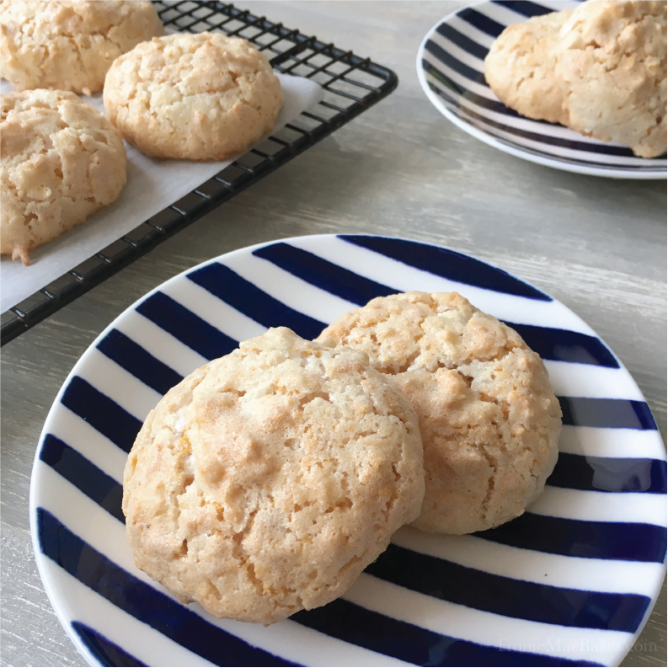
Sweet Cornflake and Coconut Macaroons
www.FronieMaeBakes.com
Ingredients:
- 2 egg whites
- 3/4 cup of sugar
- 2 cups of Corn Flakes
- 1 cup of sweetened shredded coconut
Directions:
Preheat oven to 325 degrees. Beat egg whites into stiff peaks. Gently fold sugar into egg whites until combined. Crush corn flakes and add coconut. Gently fold corn flakes and coconut into egg white and sugar mixture until incorporated. Using a teaspoon or small cookie scoop place cookie batter on a parchment lined (or greased) cookie sheet. Bake for 13-18 minutes, until golden brown on the edges. Let cookies cool completely on pan, as they are even more fragile while hot. Store in an airtight container.
Makes approximately 2 dozen.

